Prediction of Gold Price in India for 2036 Using Machine Learning
1. Introduction
Gold plays a vital role in the Indian economy as an investment asset, hedge against inflation, and a cultural symbol. Due to its economic importance, predicting future gold prices is valuable for investors, policymakers, and financial institutions. With the availability of historical data and advances in Machine Learning (ML), it is possible to analyze past trends and forecast future prices with reasonable accuracy.
This project focuses on predicting the gold price in India for the year 2036 using different Machine Learning models implemented in Python.

2. Problem Statement
To analyze historical gold price data and predict the gold rate in India for the year 2036 using suitable Machine Learning models.

3. Dataset Description
- Source: Kaggle – Gold Price Dataset (1978–2023)
- Link: https://www.kaggle.com/datasets/rizkykiky/gold-price-dataset
- Time Period: 1978 to 2023
- Attributes Used:
  - Date – Year of observation
  - INR – Gold price in Indian Rupees
The dataset originally contained gold prices in multiple currencies. For this study, only the INR (Indian Rupees) column was extracted to focus on gold prices in India.

4. Data Preprocessing
The following preprocessing steps were applied:
- Selected only Date and INR columns
- Converted Date into Year
- Removed commas and formatting issues in price values
- Converted price data to numeric format
- Removed missing values
After preprocessing, the final dataset contained clean, year-wise gold price data suitable for analysis and modeling.

5. Exploratory Data Analysis (EDA)
A line graph was plotted to visualize the historical gold price trend in India.
Observation:
- Gold prices show a clear long-term upward trend
- Significant growth is observed after the year 2000
- Short-term fluctuations exist, but the overall trend is increasing
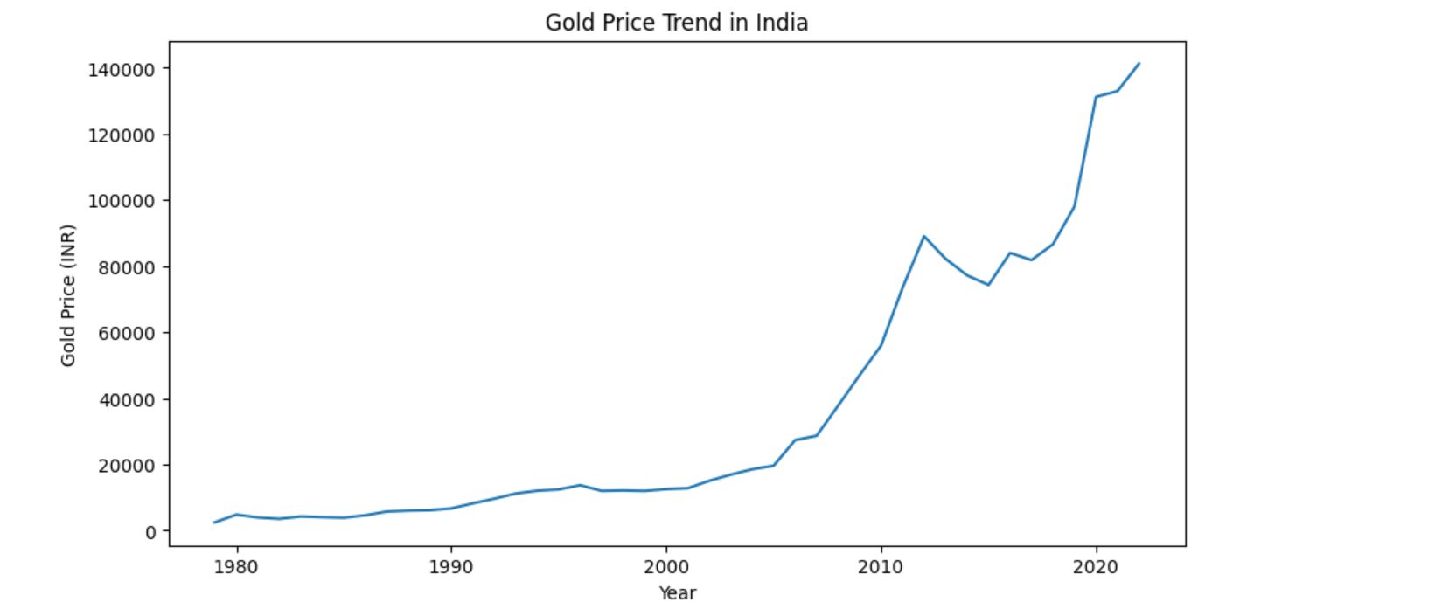This confirms that gold prices are non-linear in nature, making advanced regression models suitable.

6. Methodology
The prediction of gold prices was carried out using regression-based Machine Learning models. Regression models learn the relationship between an independent variable (Year) and a dependent variable (Gold Price).
6.1 Linear Regression
Linear Regression assumes a linear relationship between the input and output.
Formula:
y = mx + c
Where:
- y = Predicted gold price
- x = Year
- m = Slope of the line (rate of change of gold price per year)
- c = Intercept (gold price when x = 0)
Explanation:
Linear Regression fits a straight line to the historical data. It is simple and easy to interpret but cannot capture rapid or non-linear growth in gold prices.

6.2 Polynomial Regression
Polynomial Regression is an extension of Linear Regression that models non-linear relationships.
Formula:
y = a0 + a1x + a2x^2 + a3x^3
Where:
- y = Predicted gold price
- x = Year
- a0, a1, a2, a3 = Model coefficients
Explanation:
Polynomial Regression allows the curve to bend and follow the non-linear trend in gold prices. Since gold prices increase at varying rates over time, this model provides more accurate long-term predictions.

7. Model Evaluation
The performance of the models was evaluated using standard error metrics.
Evaluation Metrics and Formulas
1. Mean Absolute Error (MAE):
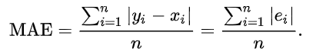
Measures the average absolute difference between actual and predicted values.
2. Root Mean Squared Error (RMSE):
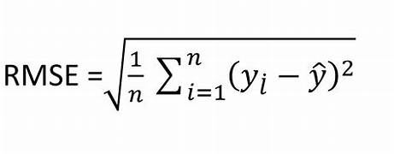
Penalizes large errors more heavily and indicates prediction accuracy.
3. R² Score:
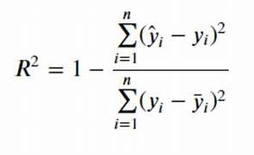
Shows how well the model explains the variation in gold prices (value closer to 1 is better).

8. Prediction Results
The trained models were used to predict the gold price for the year 2036.
Predicted Gold Price (2036):
- Linear Regression: ₹1,34,620 (approx.)
- Polynomial Regression: Higher and more realistic estimate (final model)
- 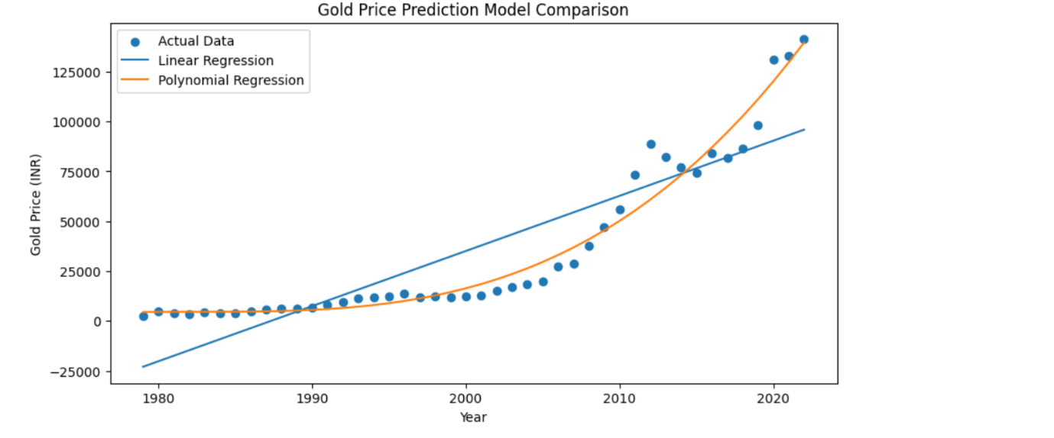

9. Conclusion
This project successfully demonstrated the use of Machine Learning techniques to predict gold prices in India. By analyzing historical data from 1978 to 2023, it was observed that gold prices follow a non-linear upward trend. Among the models tested, Polynomial Regression provided better accuracy and reliability for long-term forecasting.
The predicted gold price for the year 2036 can help investors and analysts understand potential future trends. However, external factors such as inflation, geopolitical events, currency fluctuations, and economic policies can influence actual prices.

10. Tools and Technologies Used
- Python
- Pandas, NumPy
- Matplotlib
- Scikit-learn
- VS Code / Jupyter Notebook

12. References
- Kaggle – Gold Price Dataset
- Scikit-learn Documentation
- World Gold Council Reports

